Table of Contents
Recommended API Gateway Approach in OCI 2
OCI API Gateway Service (Primary Recommendation) 2
Recommended Architecture Pattern 3
Typical stack: 3
Common Deployment Models 3
Common/Recommended Practices 3
When to Consider Alternatives 4
Recommendations Summary 4
References 5
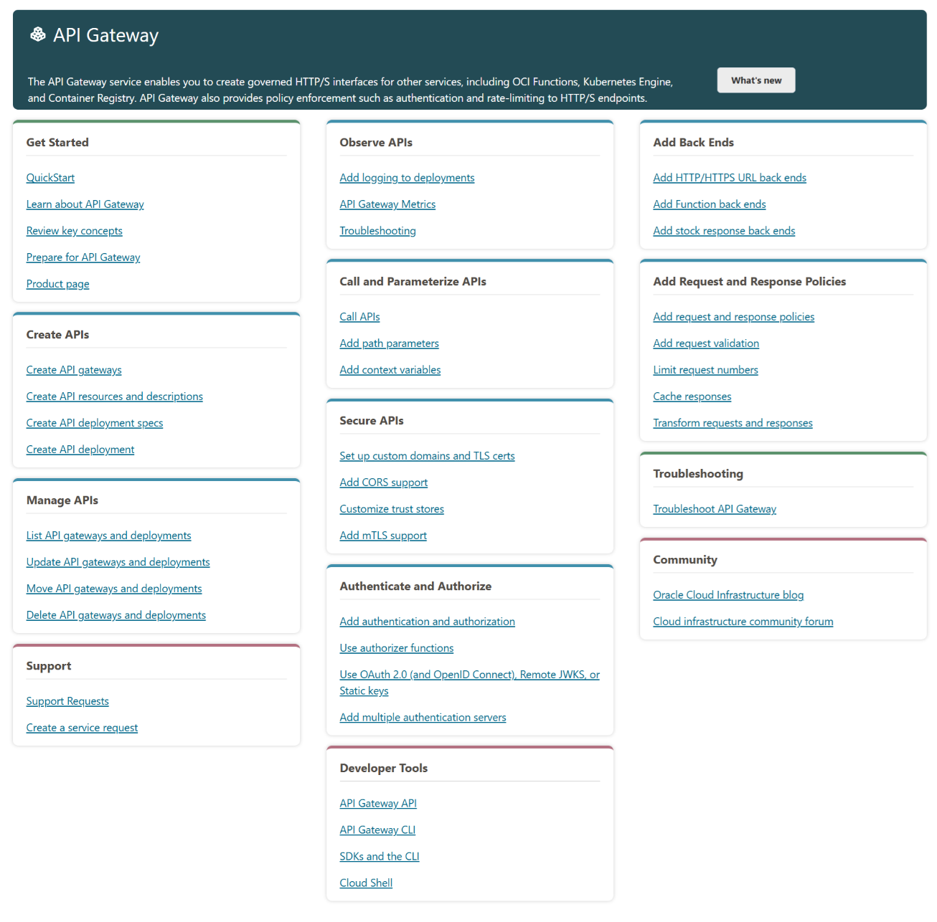

Recommended API Gateway Approach in OCI
Oracle Cloud Infrastructure (OCI) provides a native API Gateway service as the recommended approach for managing APIs.

OCI API Gateway Service (Primary Recommendation)
OCI API Gateway is a fully managed, serverless regional service that lets you publish APIs with private or public endpoints, route requests to backend services, and apply API access and API usage policies — without managing infrastructure.
Key capabilities:
- Routing — Route API calls to OCI Functions, HTTP backends, OCI Object Storage, or Stock Responses
  - You can use Static/Dynamic/Wildcards/Conditional routings to one or multiple backends on a routing rule within one API GW Deployment to API GW instance.
- Authentication & Authorization — Supports JWT validation, custom authorizers via OCI Functions, and OAuth 2.0
  - You can use No/Single Authorization Server/Multiple Authorizers with Conditional authorization within one API GW Deployment to API GW instance.
- Rate Limiting & Throttling — Control request rates at the API Deployment or Route level.
- Request/Response Transformation — Modify headers, query params, and body.
- CORS support — Built-in Cross-Origin Resource Sharing configuration
- TLS Termination — Handles HTTPS with custom certificates via OCI Certificates service.
- Observability — Integrated with OCI Logging, Metrics, and Monitoring and OCI Log Analytics with OOTB analytics dashboards with possibility to deep dive to logs.

Recommended Architecture Pattern

Client → OCI API Gateway → Backend (OCI Functions / Compute / Kubernetes / External HTTP)
↓
OCI IAM / JWT Authorizer / Custom Authorizer
↓
OCI Logging & Monitoring

Typical OCI stack:
Layer | OCI Service
DNS | OCI DNS
TLS/Certs | OCI Certificates
API Management | OCI API Gateway
Auth | OCI IAM / IDCS / Custom JWT
Compute/Logic | OCI Functions (serverless) or OKE
Observability | OCI Logging, APM, Monitoring

Common Deployment Models
1. Public API Gateway
- Accessible over the internet
- Best for external-facing APIs
- Assign a public IP/hostname.
2. Private API Gateway
- Accessible only within a VCN (Virtual Cloud Network)
- Best for internal microservices or intranet APIs
- No public exposure

Common/Recommended Practices
- Use VCN-native endpoints — Place the gateway in a dedicated subnet with proper Security Lists/NSGs
- Leverage OCI Functions as authorizers — For custom auth logic (API keys, custom tokens)
- Enable logging — Send access logs to OCI Logging for audit and debugging.
- Use Usage Plans — Control and monetize API consumption per subscriber.
- Separate deployments per environment — Use distinct API deployments for dev/staging/prod.
- Apply rate limiting early — Protect backends from traffic spikes at the gateway level

When to Consider Alternatives
Scenario | Alternative
Full API lifecycle management (portal, versioning, analytics) | OCI API Management (built on top of API Gateway)
Kubernetes-native API routing | OCI Kubernetes (OKE) + Ingress Controller (e.g., NGINX / Traefik)
Service mesh (east-west traffic) | OCI Service Mesh
Legacy or third-party gateway | Kong, Apigee (on OCI Compute)

Recommendations Summary
For most use cases on OCI, the native OCI API Gateway is the recommended approach due to its serverless nature, deep OCI integration, and zero infrastructure management.
Pair it with OCI Functions for custom logic and OCI IAM/IDCS for identity — and you have a production-ready, scalable API platform.

References
Product Capabilities
- OverviewOracle's primary documentation covering the service overview, IAM integration, and capabilities.
- HomeThe top-level documentation hub for the API Gateway service.
- ConceptsCovers public vs. private gateways, usage plans, rate limits, quotas, subscribers, and entitlements.
- Creating an API GatewayStep-by-step guide for creating public and private gateways via CLI and Console.
- Limiting the Number of Requests to API Gateway Back EndsOfficial documentation on rate limiting policies.
- OCI API Gateway - Release Notes History of features including JWT auth, OCI Certificates integration, response caching, CORS, and Usage Plans.
Reference Architectures
- OCI API GatewayOracle reference architecture for connecting multi-cloud microservices via API Gateway.
- Disaster Recovery Reference Architecture — OCI API Gateway Covers HA, cross-region DR, NSGs, Security Lists, and deployment synchronization.

